

Name........................................................................................................

Batch.........................................................................................

|  |  |  |
| --- | --- | --- |
| GRADE – X CBSE |  | TOTAL MARKS 28 |
| DATE: 2ND FEBRUARY,2023 | SUBJECT:MATHS-POLYNOMIALS | 1HRS |

Solution:  
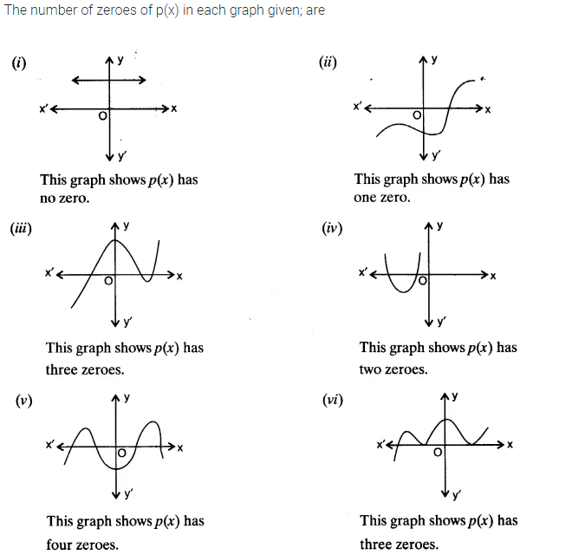

Solution:  
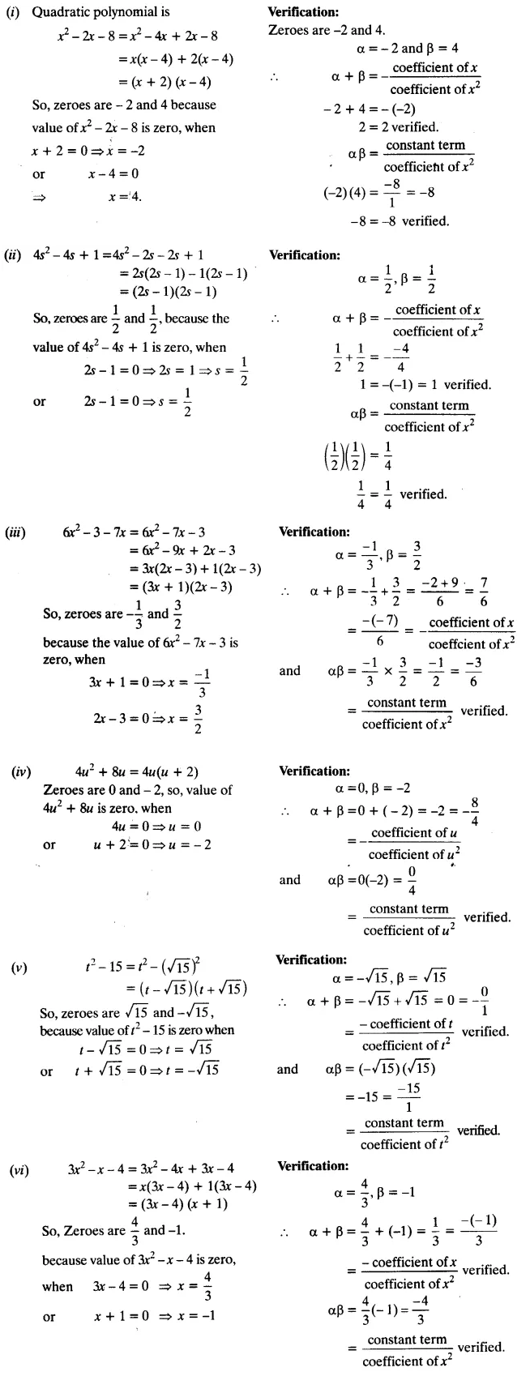

Solution:  
