**Std. : 8th CBSE Date : 18/06/2017**

**Sub : Maths Marks : 30 Time : 1 hr.**

1. If three angles of a quadrilateral are each equal to 75°, find fourth angle. **[01]**

2. Find the sum of all angles of a pentagon. **[01]**

3. The adjacent angles of a parallelogram are (2x – 4) and (3x – 1) find measures of all angles of the parallelogram **[03]**

4. A playground in the town is in the form of a kite. The perimeter is 106 m. If one of its side is 23 m, what are the lengths of other three sides? **[03]**

5. In rectangle ‘PAIR’ find nd  **[03]**

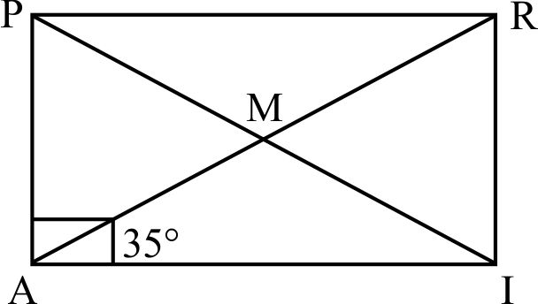

6. In parallelogram ABCD, find  &  **[03]**

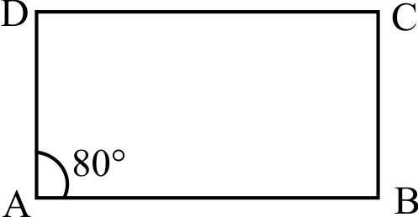

7. Find value of x + y in following parallelogram **[04]**

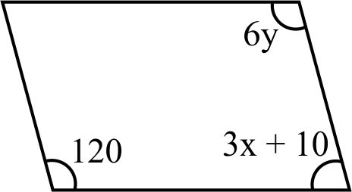

8. Find value of x in trapezium also find  **[04]**

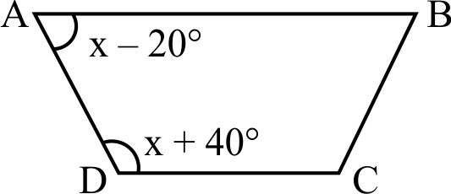

9. ABCD is a trapezium such that AB | | CD,  find angles of trapezium **[04]**

10. In following figure FD | | BC | | AE and AC | | ED. Find value of x. **[04]**

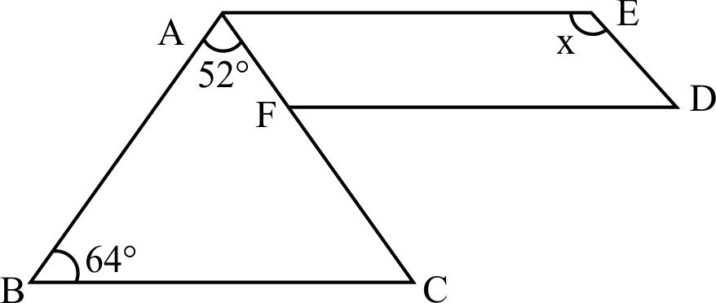

**\*Best of Luck**