

**Centre: Vastrapur**

**Date: 23/07/2017 Grade: 10th CBSE**

**Subject: Mathematics 30 Marks 1 Hour**

**Chapter: 6 Triangles**

**Q.1** In ∆ABC, DE is Drawn **[02 Marks]**

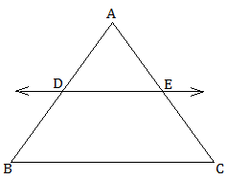

In Given Figure,

Where, AD = 2.4cm; BD = 7.2cm

AE = 1.8cm; EC = 5.4cm

DE || BC

Prove That

**Q.2** In figure if ∠M || CB &∠N || CD Prove that  **[03 Marks]**

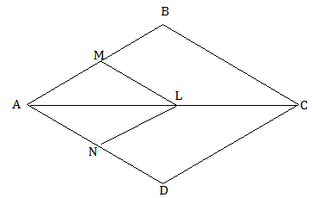

**Q.3** In figure DE||OQ and DF||0/2 then show that EF||QR **[04 Marks]**

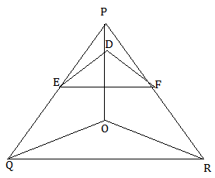

**Q.4** **[04 Marks]**

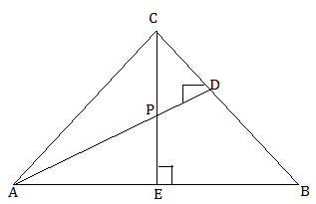

Prove that:

1. ∆ AEP ~ ∆ CDP
2. ∆ ABD ~ ∆ CBE

**Q.5** E is A point on side CB produced on an isosceles ∆ABC with AB=AC. If ADAC Prove that ∆ABC ~ ∆ECF **[04 Marks]**

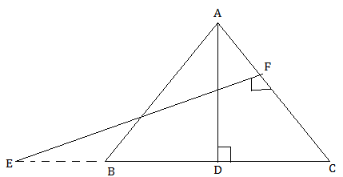

**Q.6** ABCD is a parallelogram. AE Divides the line segment BD in the ratio of 1:2 if BE = 1.5cm find BC. **[04 Marks]**

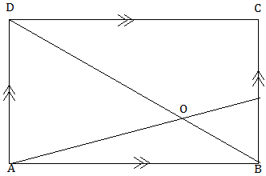

**Q.7** In Figure DE||BC. If DE:BC=3:5 than find  **[04 Marks]**

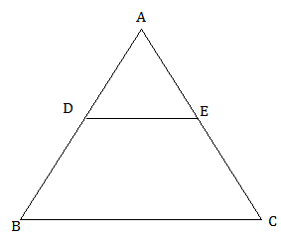

**Q.8** Diagonal of quadrilateral ABCD intersect each other at point O. Such that than show that ABCD is a trapezium. **[03 Marks]**

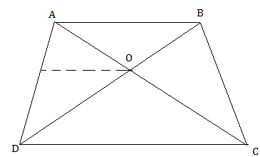

**Q.9** **[02 Marks]**

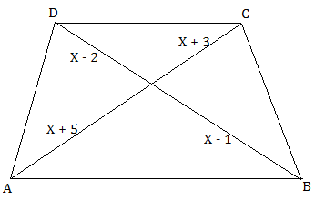

In Given Figure

AB || CD

Find X.

**‘All the best :)’**