

**Centre: Prahladnagar**

**Date: 16/07/2017 Grade: 10th CBSE**

**Subject: History 40 Marks 2 hours**

**Nationalism in Europe**

**(A) MCQs: Select any one. (0.5 mark each) [3]**

1. In his prints, what type of world was visualized by Frédéric Sorrieu?

Absolute Monarchies; Constitutional Monarchies; Oligarchies; Democratic and Social Republics

2. When did Nationalism begun?

1700; 1750; 1800; 1900

3. False feature about Liberal Nationalism in Europe.

Freedom for the individual; Concept of government by consent; A constitution and direct democracy; Equality for all before the law.

4. Treaty of Constantinople- who got independence?

Bulgaria; Hungary; Greece; Serbia

5. Who relates with ‘blood and iron’?

Mazzini, Bismarck; Cavour; William I

6. Which nation did Marianne represent?

England; Germany; Austria; France

**(B) Mention: (1 mark each) [4]**

1. Distinction between Nationalism and Imperialism.

2. What was the Balkan problem?

3. What is the political idea supported by ‘Liberalism’?

4. ‘The Act of ________’ in ________ formed ‘United Kingdom of Great Britain’.

**(C) Explain in short: (2 points each; 2 mark each) [6]**

1. Nationalism in your own words.

2. ‘Young Italy’- what was it?

3. Cause and the result of the Silesian weavers’ uprising.

**(D) Explain giving suitable reasons: (3 marks each) [12]**

1. Who was Napoleon and what was his role?

2. Describe the social condition (reaction of the commoners) in Europe during Nationalism.

3. Short-note on Romanticism.

4. ‘The relations between Germany and Italy’- give their significance in the era of Nationalism.

**(E) Give detailed answers: (5 marks each) [10]**

1. How is the French Revolution related to Nationalism in Europe?

2. Trace the process of German unification.

**(F) Map work; do as directed: (1 mark each) [5]**

Europe after the Congress of Vienna**-**

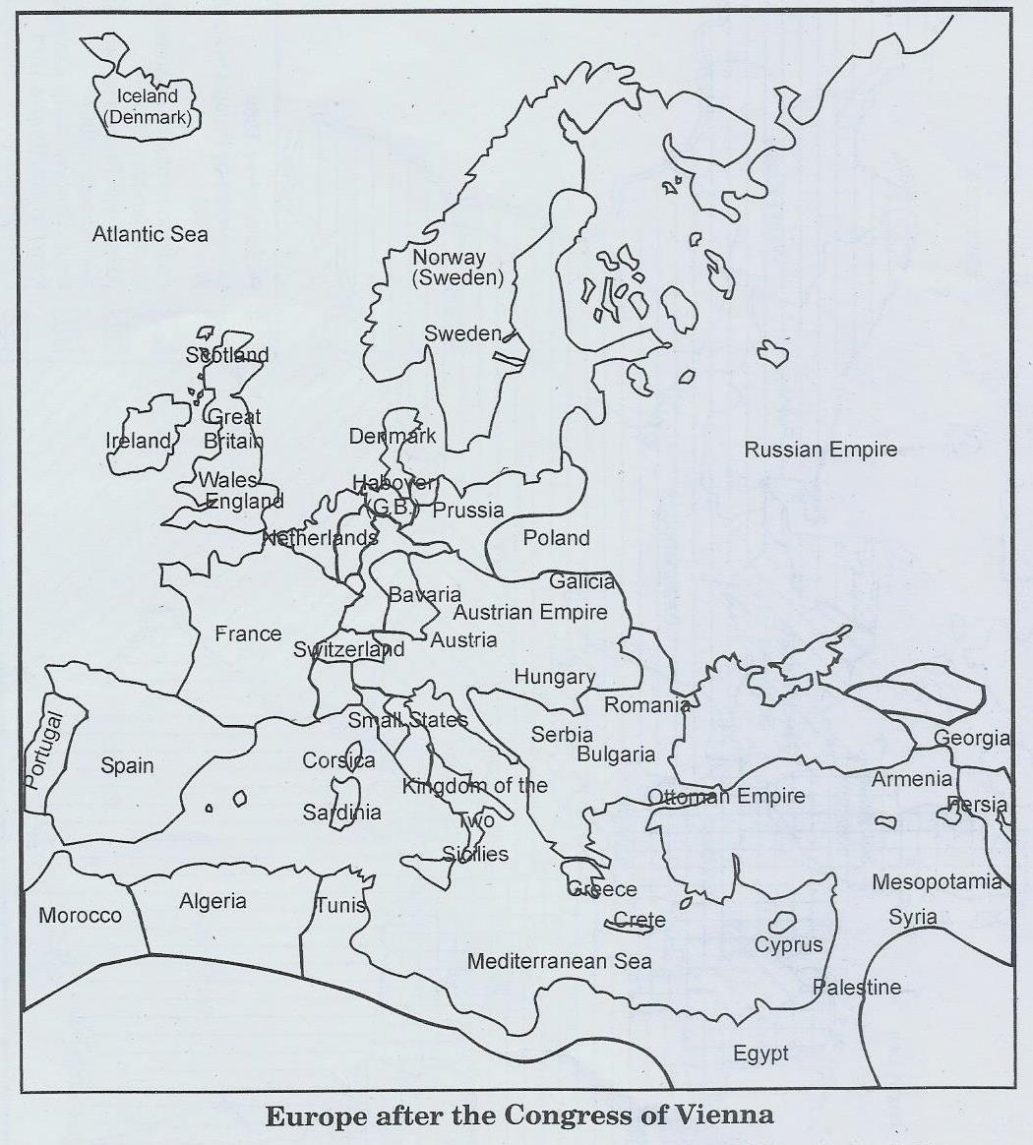

1. What was the main aim of the Congress of Vienna? 2. Which countries unified to prevent French expansion in the future? 3. Where was the Bourbon dynasty restored? 4. By which countries’ part did Russia benefit? 5. What was the change made in the German confederation?

**All the best :)**